

Skyward 101 Essentials

Attendance-

You can take attendance through **Post Daily Attendance** by using either **Take Daily Attendance-By Name** or the **Take Daily Attendance-By Seating Chart**. You can also take attendance by going to the Attendance tab in the Gradebook.

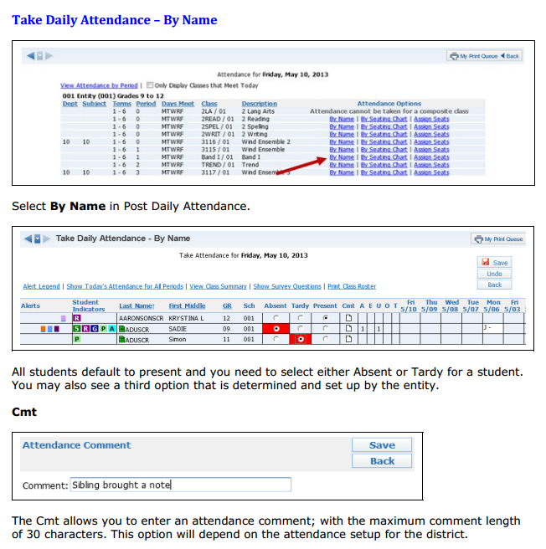

**Note Teachers can view **Alert legend** that will show if students fall under different categories. They can also use different options to change the view and view additional information.

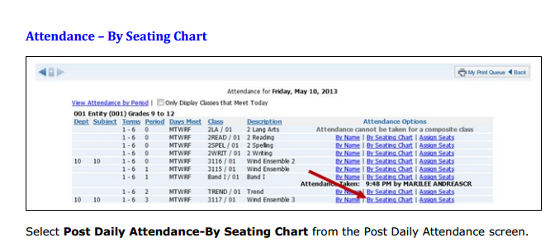

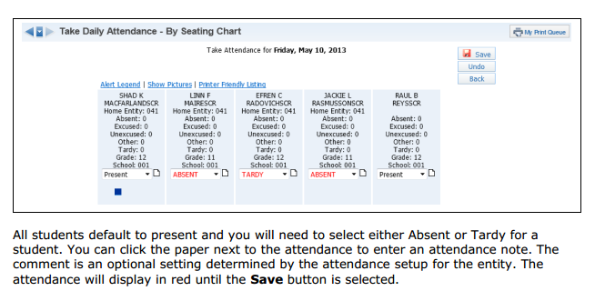

**Note Teachers can view **Alert legend** that will show if students fall under different categories. They can also show pictures if they are loaded and print out a seating chart if they would like (seating chart setup is on previous page)

Student Info + Discipline

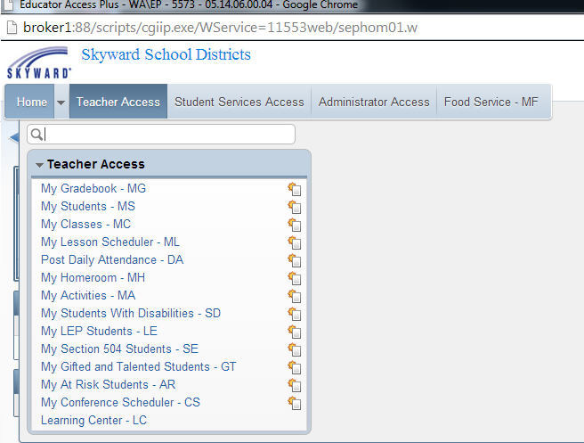

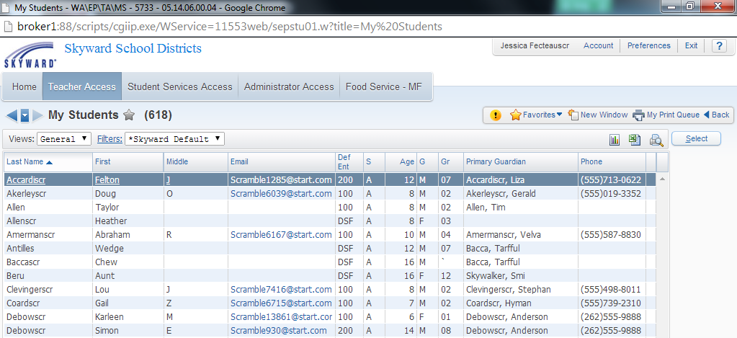

After clicking on **My Students**, you will see a list of students **currently enrolled** in one of your classes. You will highlight the student for whom you want to view information and click on **Select.**

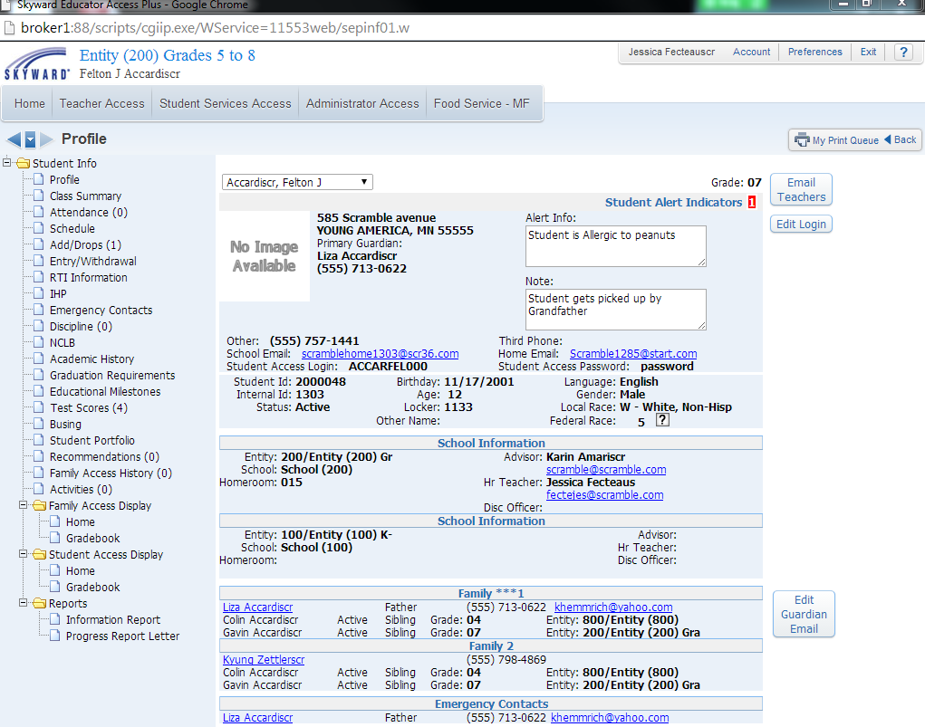

The **student’s info** will load and teachers can now choose options to the left in order to view different student information (some things could be different due to configuration). **Profile** page will show student demographics as well as emergency contacts.

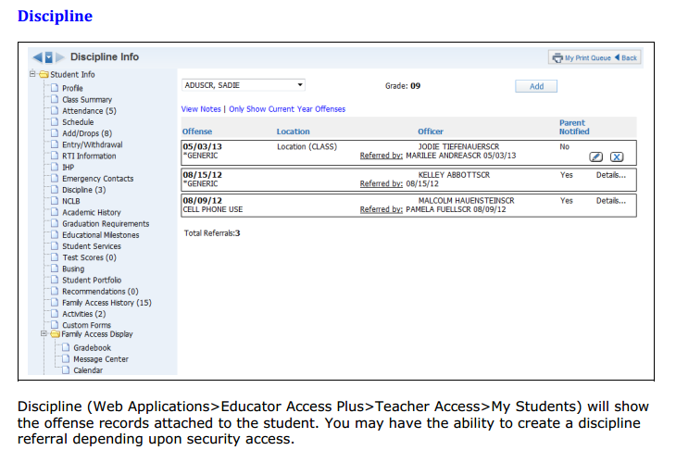

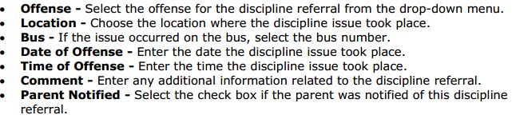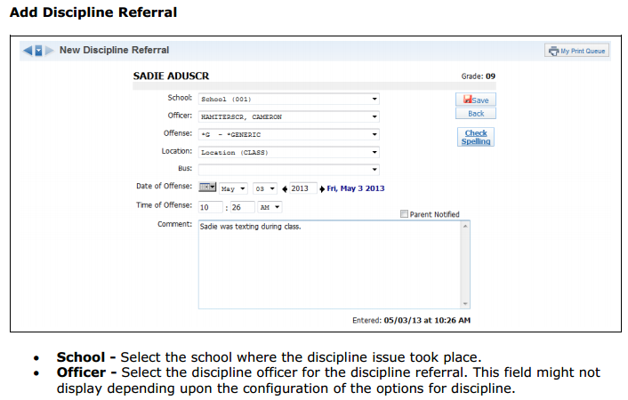

** Note other areas in the Student’s Info including Discipline tab may be different because of configuration.

Gradebook

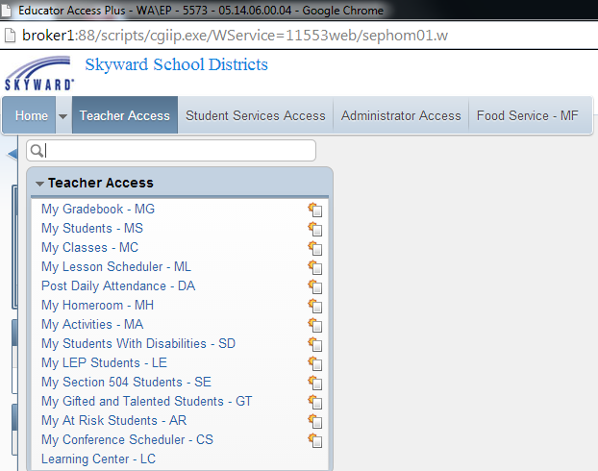

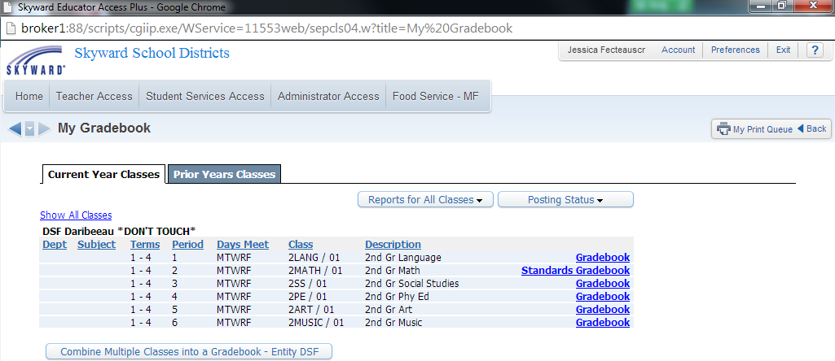

This is the **My Gradebook** screen. From this screen, you are able to access all of your **current classes’** Gradebooks along with those from any past years during which you used the skyward software. Classes will be grouped together based on the entity in which they are taught, so if you teach in multiple entities, your classes will be split into groups. **Standards gradebook is the one you will be working with.**

Standards Gradebook

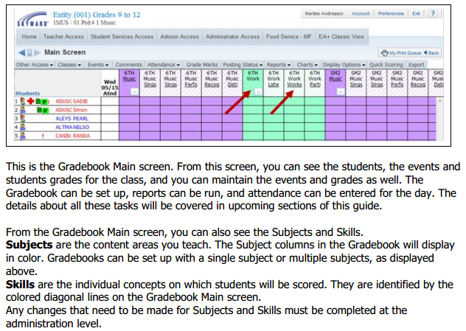

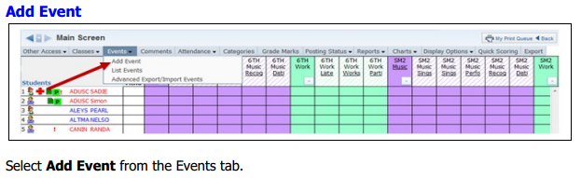

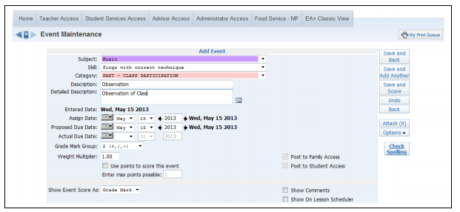

\*\***Subject**: Select a subject from the drop-down menu. The subjects displaying are set up by the district administrator.

\*\***Skill**: Select a skill from the drop-down menu. The skills that appear in this area depend on the subject selected.

Category: Select a category code from the drop-down menu. Note: The event category codes are maintained by the administration. The Category drop-down menu displays because of the district gradebook setup.

\*\***Description**: Enter the description of the event (maximum of 30 characters).Example: Spelling Test, Worksheet 1B

**Detailed Description**: Enter a detailed explanation of the event (maximum of 300 characters). The Detailed Description can be viewed within Family and Student Access. Click the icon to access a larger window for descriptive details. Example: Spelling Test covering household objects

\*\***Assign Date**: Enter the date the event was given to the students; it defaults to the current date.

\*\***Proposed Due Date**: Enter the date you anticipate that the event will be due. You can enter future Assign and Prop

**Use points to score this event**: If flagged, you can enter the maximum value a student may receive for the event; extra credit should not be included in this number. The option to use points will depend on how the gradebook was set up by administrators. If you do not select to use points to score this event, you will subjectively score the students with a Grade Mark instead of numeric score. Depending upon the gradebook setup, you might not have a choice to use points. In this case, you will just see an option for Enter Max Points Possible.

** required fields

** Also note that on the bottom of the ‘add event’ screen you will be able to add to other subjects/skills.

Scoring Event

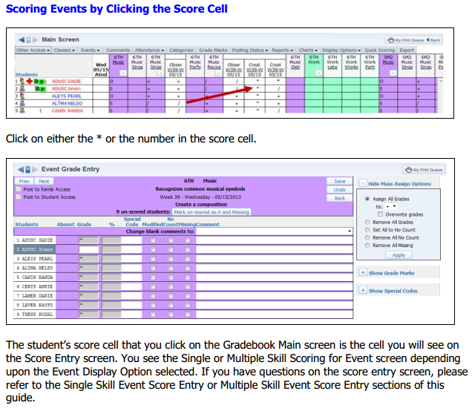

** Note that some areas within your system may be different due to configuration.